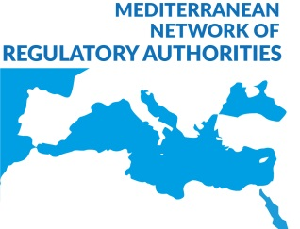
Creation of the Network of Mediterranean Regulatory Authorities
Barcelona, Catalonia, Spain, November 29 1997

Establishment of a permanent network of information exchange between
the Regulatory broadcasting Authorities of the Mediterranean Countries

On Saturday 29 November 1997 was signed by representatives of the Regulatory Authorities of France, Portugal, Italy, Greece and Catalonia an agreement for the establishment of a permanent network of audiovisual media regulatory authorities of the Mediterranean in order to establish a platform for discussion, information exchange and research on broadcasting regulation.

The agreement was signed by Mr Hervé Bourges, President of the Conseil supérieur de l’audiovisuel of France (CSA), Mr Eduardo Trigo, Vice President of the Alta Autoridade para a Comunicação Social of Portugal (AACS), Mr Antonis Manitakis, Vice President of the National Radio and Television Council of Greece (CNRTV), Mr Giorgio d'Amato, General Secretary of the Ufficio del Garante per la Radiodiffusione e l’Editoria of Italy, and Mr Luis Carreras, President of the Consell Audiovisual de Catalunya (CAC).

The signature of this agreement is the most important outcome of the first meeting of the regulatory authorities of the Mediterranean countries members of European Union which was held this weekend in Barcelona under the patronage of the Conseil supérieur de l’audiovisuel of France (CSA) and the Consell Audiovisual de Catalunya (CAC). During these two days of work, the participants exchanged information on the common problems they are to face as well as the different regulatory frameworks governing the operation the audiovisual regulatory authorities present at this meeting. The participants also decided to hold an annual meeting and to set up a Permanent Secretariat headquartered in the Conseil supérieur de l’audiovisuel of France (CSA).

The second meeting will be held next year in Athens under the auspices of the National Radio and Television Council of Greece (CNRTV).

The participants were received by the President of the Catalan Parliament Mr Jean Revenos and the Minister of the Presidency of the Catalan Government, Mr Xavier Trias.

Barcelona, 29 November 1997

